Zonta Memorial Donation Request

In Memory of

Date: ______________ Donation amount $ ______________

To: ______________________________________________

From: ____________________________________________

Address: ____________________________________________________________________________________________________
__________________________________________________
Payment can be made through Venmo or by Check payable to Zonta Club Bradford, PO Box 743, Bradford, PA 16701 Attn: Club Treasurer.
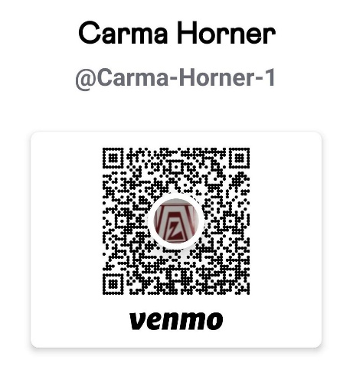
Memorial will be sent once payment has been received.

